# What is Sass?

Sass: Syntactically Awesome Style Sheet.

Extension to CSS. (CSS Pre-Processor)

* Easy to manage
* Increase Coding Speed
* Cross Browser Compatible

(Only for bigger project, for small project using Sass is not beneficial, not for 4, 5 pages websites)

# How to Use Sass File in HTML:

* We Can’t Use Sass File in Html
* Browser Can’t Understand Sass Code

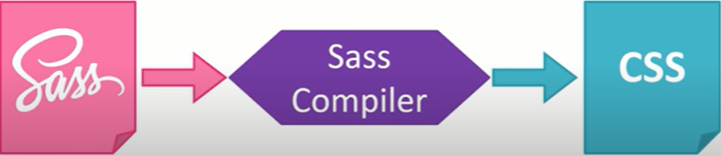

# Features of Sass:

* Variables
* Nesting’s
* Partials & Imports
* Mixins
* Extends
* Operators
* Functions
* Conditional Directives
* Loops

# How to write Sass Code:

Scss Syntax Sass Syntax CSS Syntax

nav { nav nav ul {

ul { ul margin: 0;

margin: 0; margin: 0 padding: 0;

padding: 0; padding: 0 list-style: none;

list-style: none; list-style: none }

} nav li {

li { li display: inline-block;

display: inline-block; display: inline-block }

} nav a {

a { a display: block;

display: block; display: block padding: 6px 12px;

padding: 6px 12px; padding: 6px 12px text-decoration: none;

text-decoration: none; text-decoration: none }

}

}

Prerequisite for Learning Sass:

* HTML
* CSS